TO: DK 4-H Cloverbud Members

RE: CKFF

The Central Kansas Free Fair is not far off. This letter will give you some basic information about exhibits that you may enter in the fair.

**General Entry Information**

1. **All** Cloverbud exhibits are exhibited in class #832 under “Other Projects”. This means that ***any exhibit*** that you choose to enter will have that class number, **no matter what the exhibit is.** **For 2025 add FairEntry file path – Sterl Hall – Other Projects. – Cloverbud**

2. Each Cloverbud may enter a **total** of **two** exhibits.

3. Each Cloverbud will receive a participation ribbon and a $1 premium per exhibit. The premium money is scheduled to be available at the Extension Office after August 30.

4. Cloverbud projects must be pre-entered by **July 10** at [www.ckff.fairentry.com](http://www.ckff.fairentry.com). You will be able to choose your **Saturday, July 26** judging time(s) when you pre-enter.

5. Exhibits will be entered at the time of conference judging.

6. We’re anticipating the area for “Other Projects” will be along the center of the north wall in the large room at Sterl Hall. Staff and volunteers will be around to help with directions.

**Judging Information**

1. Conference judging is not required, but is a very good learning experience. It will give you a chance to talk with the judge about your exhibit and answer any questions the judge might have for you. Some expectations and hints about conference judging are included below.

2. All judging for Cloverbuds will be on **Saturday, July 26**.

3. Those that plan to exhibit a pet and want to bring in the animal must pre-enter for a Saturday judging time. Bring the pet in on Saturday for judging and as soon as judging is complete, you may take your pet home. The pet must be on the approved list from the State 4-H program. **Approved Pets:** Amphibians, Frogs, Toads, Ant Farms, Cats, Dogs, Fish, Rabbits, Gerbils, Guinea Pigs, Hamsters, Mice, Rats, and Parakeets.

4. Cloverbud **Foods**: Pre-enter for a Saturday judging time, then bring the food item in at that time. Cloverbud food entries are **NOT** judged in the 4-H foods department, they will be judged in the “Other Projects” area with the rest of the Cloverbud projects.

5. Any Cloverbud exhibit considered too fragile or too valuable to be on display throughout fair week may be taken home as soon as it is judged (examples: Stamp Collections, Card Collections, Beanie babies).

6. Cloverbuds are welcome to enter Open Class. These are not conference judged but give an opportunity to have their work displayed and maybe win a ribbon and premium money. Several Open Class divisions like crafts, fine arts, and floriculture include youth classes. Open Class entries are not required to be pre-entered but it’s helpful to our office if they are. Links to the Premium Guide and FairEntry system may be found on our district [CKFF page](https://www.chisholmtrail.k-state.edu/fairs/ckff/CKFF.html).

We hope that being a Cloverbud this year has been fun for you, and we look forward to seeing you again next year. Have fun with your exhibits and enjoy the Central Kansas Free Fair!

**Conference Judging**

**Purpose:** the judge wants to learn more about you and your project.

**What to expect:** conversation and questions about your project…

* Tell me about how you selected this particular

exhibit to compete this year for fair.

* What was your favorite part of this exhibit?
* What was the most important thing you learned?
* If you had the chance to do this exhibit again,

what would you change?

* How did you choose _____ for your exhibit?
* Where did you learn how to _____?
* Tell me more about ______.
* What part was the most difficult?
* What was the easiest?
* How will you use what you learned next time?

**Hints**

* Keep eye contact with the judge.
* Sit attentively in your chair, try not to wiggle around.
* No gum!
* Speak to the judge, answer questions directly.
* Even though they may be sitting nearby, avoid looking to your parents for information.
* Listen carefully to the feedback the judge gives.
* Ask questions!
* Practice!

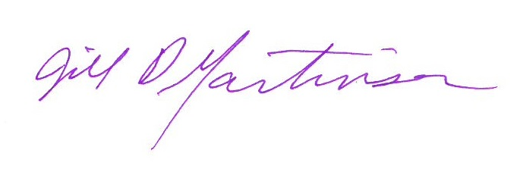

Jill D. Martinson

Chisholm Trail District 4-H Youth Development Agent

[martinso@ksu.edu](mailto:martinso@ksu.edu)

785-263-2001